**Bitcoin Investment Risk**

You are interested in buying and holding Bitcoin and would like to understand the potential ROI, expected holding time, and overall risk (of losing an investment or negative ROI). You want to base your understanding on recent historical returns which are of course no guarantee of future returns, so you will also want to understand what confidence you can have in your analysis results.

1. Obtain Bitcoin closing price data from the present to three years past

install.packages("Quandl")

library(Quandl)

> BTC_data = Quandl("BCHAIN/MKPRU", start_date="2015-12-31", end_date="2018-03-29")

> plot(BTC_data, type="l")

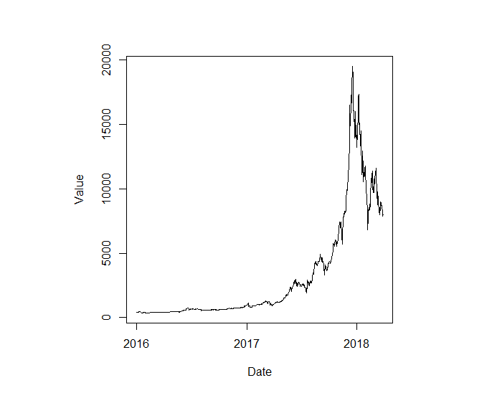

reverse the dates

> BTC_data <- BTC_data[seq(nrow(BTC_data),1,-1),]

> BTC_data$cum <- cumsum(BTC_data$Value)

> plot(BTC_data[,c(1,3)], type="l")

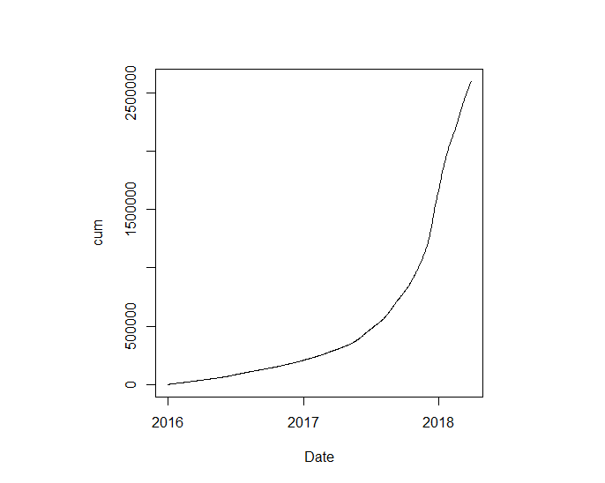

Looks like exponential growth! Best to look at the last year or returns.

> BTC_12months <- subset(BTC_data, BTC_data$Date > BTC_data$Date[nrow(BTC_data)] - 365)

> plot(BTC_12months[,1:2], type='l')

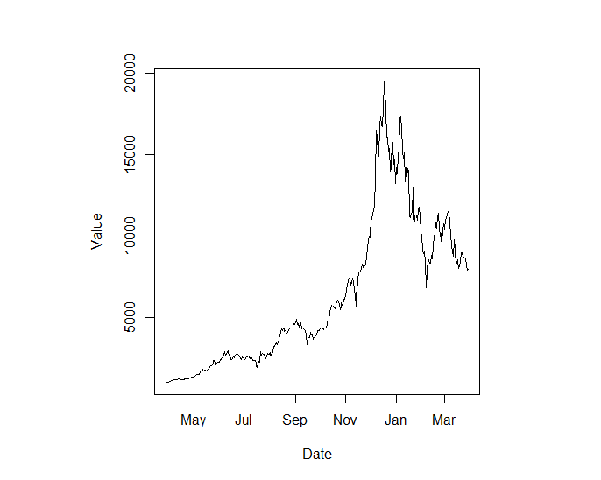

> boxplot(BTC_12months$Value)

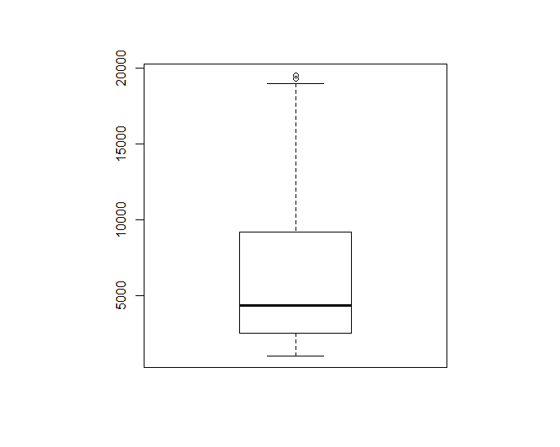

Doesn’t look Normal

> boxplot(log(BTC_12months$Value))

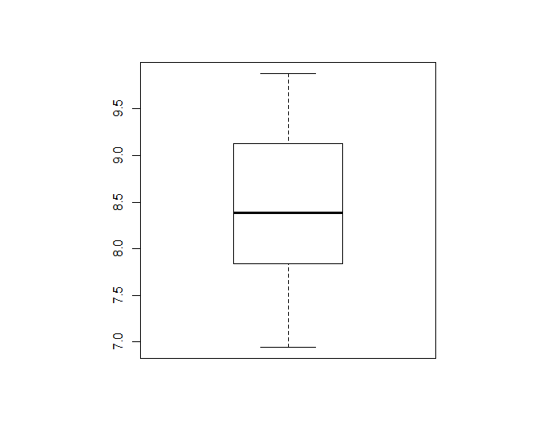

Looks Normal!

> qqnorm(log(BTC_12months$Value))

> qqline(log(BTC_12months$Value))

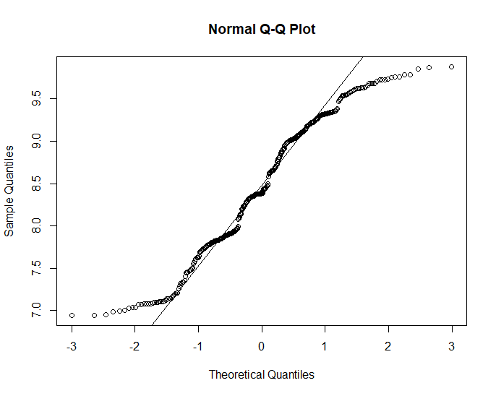

Classic fat-tail distribution for GBM. Oh my.

Get log returns

> BTC_12months$returns[2:nrow(BTC_12months)] <- diff(log(BTC_12months$Value))

Remove the first row because NA for returns

> BTC_12months <- BTC_12months[-1,]

any autocorrelation?

> acf(BTC_12months$returns)



Simulate Bitcoin prices for 1-year using GBM

We could write a monte-carlo sim to get a dist of final prices for

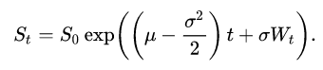

But as usual, someone wrote an R package for this (and more!).

> Dt = 1/365

> daily_vol <- sd(BTC_12months$Returns)/sqrt(Dt)

> daily_drift <- mean(BTC_12months$Returns)/Dt + daily_vol^2/2

> GBM <- function(x, r, sigma, T, N,

> install.packages("sde")

> library(“sde”)

> path <- GBM(x=BTC_12months$Value[nrow(BTC_12months)], r=daily_drift, sigma = daily_vol, T=1, N=365)

> plot(path, type='l')

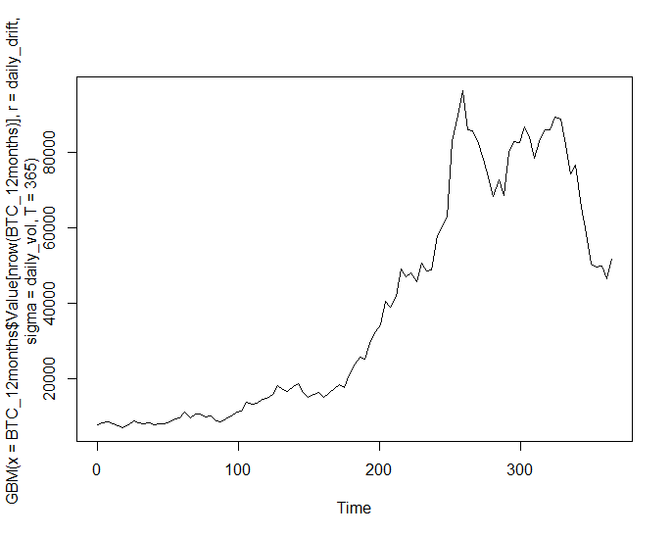

> qqnorm(log(path))

> qqline(log(path))



Looks like Bitcoin prices from last year. Check!

Let’s get a bunch of possible prices for Bitcoin in 365 days.

> final_price <- path[length(path)]

> final_price

[1] 59377.81

path <- GBM(x=BTC_12months$Value[nrow(BTC_12months)], r=daily_drift, sigma = daily_vol, T=1, N=365)

plot(path, type='l')

final_price <- path[length(path)]

returns <- diff(log(path))

d_vol <- sd(returns)

d_drift <- mean(returns)

for(n in 1:1000) {

path <- GBM(x=BTC_12months$Value[nrow(BTC_12months)], r=daily_drift, sigma = daily_vol, T=1, N=365)

lines(path, col=n, type='l')

final_price <- c(final_price, path[length(path)])

returns <- diff(log(path))

d_vol <- c(d_vol, sd(returns))

d_drift <- c(d_drift, mean(returns))

}

Check that we get the same distribution parameters

> mean(d_vol)

[1] 0.05315702

> sd(BTC_12months$Returns)

[1] 0.05362828

> mean(d_drift)

[1] 0.005594419

> mean(BTC_12months$Returns)

[1] 0.005182966

GBM prices will be log-Normal, so let’s fit simulated data to this distribution

> install.packages("fitdistrplus")

> library("fitdistrplus")

> fln <- fitdist(final_price, "lnorm")

> plot(fln)



> fln

Fitting of the distribution ' lnorm ' by maximum likelihood

Parameters:

estimate Std. Error

meanlog 10.706249 0.02998408

sdlog 1.056274 0.02120186

Most likely price in a year is

> exp(fln$estimate[1])

meanlog

44633.89

If we assume this distribution for the price in a year then

> qlnorm(.025, fln$estimate[1], fln$estimate[2])

[1] 5630.704

> qlnorm(1-.025, fln$estimate[1], fln$estimate[2])

[1] 353807.3

So Prob(5630.704 < final_price < 353807.3) = .95

Emperically we see

> emp.cdf <- function(x,p) {final_price.ecdf(x) - p}

> uniroot(emp.cdf, c(0,10^6), p = .025)

$root

[1] 6384.298

$f.root

[1] -2.014504e-05

$iter

[1] 41

$init.it

[1] NA

$estim.prec

[1] 6.103516e-05

uniroot(emp.cdf, c(0,10^6), p = 1-.025)

$root

[1] 318669.2

$f.root

[1] 2.014504e-05

$iter

[1] 47

$init.it

[1] NA

$estim.prec

[1] 6.103527e-05

So empirically Prob(6384 < final_price < 318669) = .95

In terms of risk, if we buy Bitcoin on Apr 31, 2018 for $6882.532

> buy <- BTC_12months[nrow(BTC_12months),]

Date Value Returns

1 2018-03-31 6882.532 -0.04123704

Then if we sell in a year the simulated log returns are

> fn.returns <- fitdist(log(final_price/buy$Value), "norm")

> plot(fn.returns)



Let’s look at the VaR

> logReturn.VaR <- qnorm(.05, fn.returns$estimate[1],fn.returns$estimate[2] ); logReturn.VaR

[1] 0.1320908

> exp(logReturn.VaR)

[1] 1.141212

So 95% of the time we expect a return of no worse than 1.14 times the buy. That is, at least

> buy$Value * (exp(logReturn.VaR) - 1)

[1] 971.896

Hence with 95% confidence we expect to make at least (not lose!) $971. But large variability in the parameters of the fit so this estimate is highly questionable. Also, assumption of constant drift and volatility in GBM model is probably wrong. Bitcoin seems to also be subject to “shocks” that make historical volatility a poor representation.

Constant drift and volatility (diffusion) assumptions.

> install.packages("TTR")

> library("TTR")

> m<- runMean(diff(BTC_12months$Returns))

> m<-m[!is.na(m)]

> m.lin <- lm(m ~ t, data = data.frame(t=1:length(m), m=m))

> summary(m.lin)

Call:

lm(formula = m ~ t, data = data.frame(t = 1:length(m), m = m))

Residuals:

Min 1Q Median 3Q Max

-0.023757 -0.004534 0.000164 0.003953 0.031639

Coefficients:

Estimate Std. Error t value Pr(>|t|)

(Intercept) 7.348e-05 7.834e-04 0.094 0.925

t -1.076e-06 3.814e-06 -0.282 0.778

Residual standard error: 0.007365 on 353 degrees of freedom

Multiple R-squared: 0.0002255, Adjusted R-squared: -0.002607

F-statistic: 0.07962 on 1 and 353 DF, p-value: 0.778

Looks like constant drift assumption is ok.

> plot(runSD(BTC_12months$Value),type='l')

> lines(runMax(BTC_12months$Value)-runMin(BTC_12months$Value),type='l', col="red")



> vols <- runSD(BTC_12months$Return)

> vols <- vols[!is.na(vols)]

> plot(vols,type='l')



How to model Bitcoin volatility for risk assessment? Let’s look at the time dependency:

> plot(cumsum(vols))

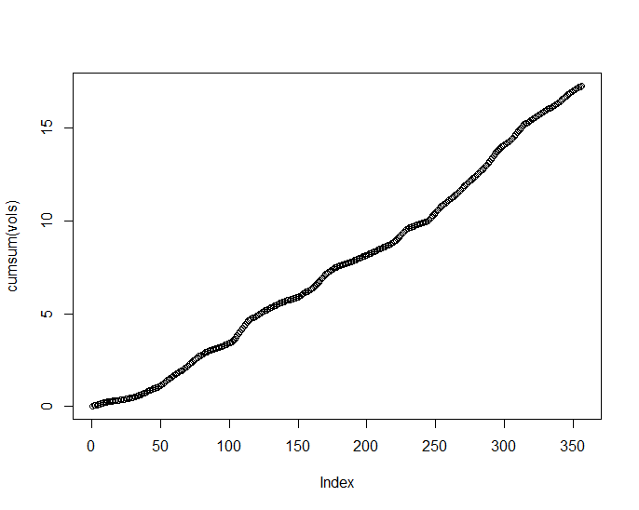

Ok, slight curve cumulative means looks more or less linear increase in volatility over time. Let’s check

> acf(vols)

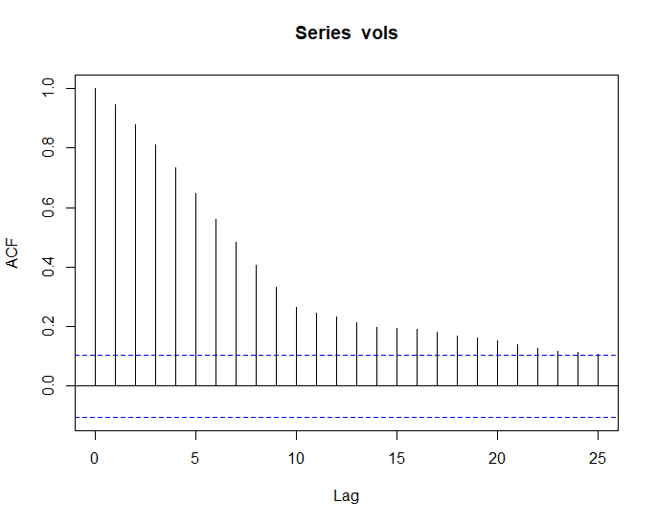

Looks non-stationary mean

> vol.lin <- lm(v ~ t, data = data.frame(t=1:length(vols), v=vols))

> summary(vol.lin)

Call:

lm(formula = v ~ t, data = data.frame(t = 1:length(vols), v = vols))

Residuals:

Min 1Q Median 3Q Max

-0.032317 -0.015923 -0.004469 0.013726 0.063493

Coefficients:

Estimate Std. Error t value Pr(>|t|)

(Intercept) 3.182e-02 2.174e-03 14.637 <2e-16 ***

t 9.420e-05 1.055e-05 8.927 <2e-16 ***

---

Signif. codes: 0 ‘***’ 0.001 ‘**’ 0.01 ‘*’ 0.05 ‘.’ 0.1 ‘ ’ 1

Residual standard error: 0.02046 on 354 degrees of freedom

Multiple R-squared: 0.1837, Adjusted R-squared: 0.1814

F-statistic: 79.68 on 1 and 354 DF, p-value: < 2.2e-16

> library(lmtest)

> dwtest(vol.lin)

Durbin-Watson test

data: vol.lin

DW = 0.13197, p-value < 2.2e-16

alternative hypothesis: true autocorrelation is greater than 0

Constant volatility assumption is NOT GOOD. Serious autocorrelation. Volatility is some time dependent probably increasing random function. Maybe Bitcoin volatility is affected by stock market volatility? Let’s compare with the VIX.

> BTC_VIXdates <- subset(BTC_data, BTC_data$Date %in% VIX_data$`Trade Date`)

> BTC_VIXdates$VIX <- VIX_data$Close

> par(mar = c(5, 4, 4, 4) + 0.3)

> plot(BTC_VIXdates[,1:2], type='l')

> par(new = TRUE)

> plot(BTC_VIXdates[,c(1,3)], type = "l", col="red", axes = FALSE, bty = "n", xlab = "", ylab = "")

> axis(side=4, at = pretty(range(VIX_data$Close)))

> mtext("VIX", side=4, line=3)



Looks like Bitcoin is negatively correlates with VIX

> par(mar = c(5, 4, 4, 4) + 0.3)

> plot(subset(BTC_VIXdates, BTC_VIXdates$Date > "2017-03-31")[,1:2], type='l')

> par(new = TRUE)

> plot(subset(BTC_VIXdates, BTC_VIXdates$Date > "2017-03-31")[,c(1,3)], type = "l", col="red", axes = FALSE, bty = "n", xlab = "", ylab = "")

> axis(side=4, at = pretty(range(subset(BTC_VIXdates, BTC_VIXdates$Date > "2017-03-31")[,3])))

> mtext("VIX", side=4, line=3)

Maybe can model with GBM

> qqnorm(vols)

> qqline(vols)

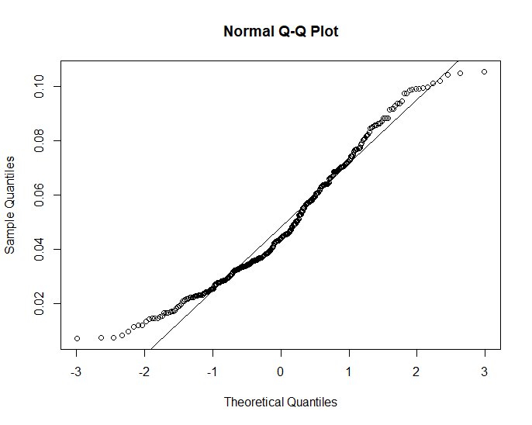



# time variying diffusion

d <- expression(daily_drift*x )

d.x <- expression(daily_drift)

s <- expression( (.5*t+daily_vol)*x )

s.x <- expression( daily_vol )

X <- sde.sim(X0=BTC_12months$Value[nrow(BTC_12months)],drift=d, sigma=s, sigma.x = s.x, T=1, N=365)

final_price <- path[length(X)]

returns <- diff(log(X))

d_vol <- sd(returns)

d_drift <- mean(returns)

plot(runSD(diff(log(X))),type='l')

for(n in 1:1000) {

X <- sde.sim(X0=BTC_12months$Value[nrow(BTC_12months)],drift=d, sigma=s, sigma.x = s.x, T=1, N=365)

final_price <- c(final_price, X[length(path)])

returns <- diff(log(X))

d_vol <- c(d_vol, sd(returns))

d_drift <- c(d_drift, mean(returns))

}

> fn.returns <- fitdist(log(final_price/buy$Value), "norm")

>

> plot(fn.returns)

> logReturn.VaR <- qnorm(.05, fn.returns$estimate[1],fn.returns$estimate[2] ); logReturn.VaR

[1] 4.289504

>

> exp(logReturn.VaR)

[1] 72.9303